Worship for June 5 & 6, 2021
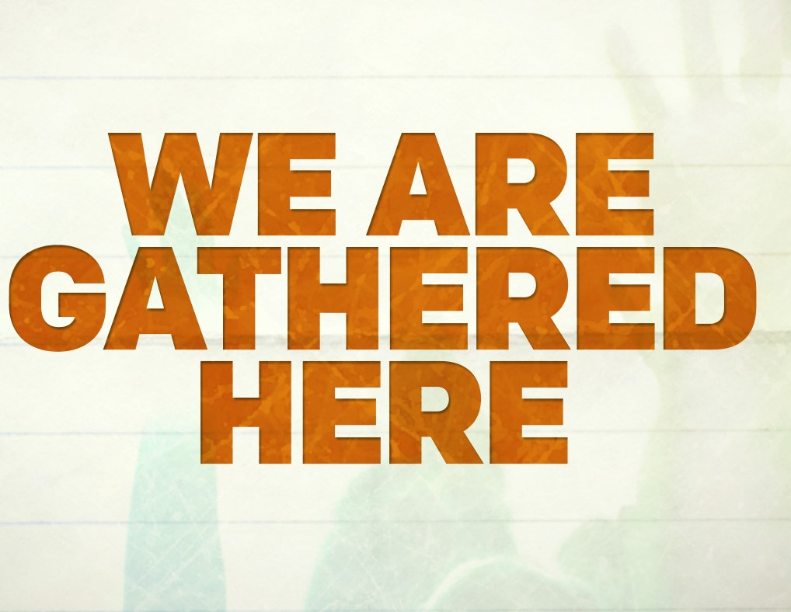
Second Sunday After Pentecost

Hymnists: Patsy Lohmer and Joy Faciane

Gathering Music: “You Are Mine” - ELW #581

1. “I will come to you in the silence, I will lift you from all your fear. You will hear my voice, I claim you as my choice. Be still and know I am here.”

2. “I am hope for all who are hopeless, I am eyes for all who long to see.
In the shadows of the night, I will be your light. Come and rest in me.”

Refrain: Do not be afraid, I am with you. I have called you each by name. Come and follow me, I will bring you home; I love you and you are mine.

3. “I am strength for all the despairing, healing for the ones who dwell in shame.
All the blind will see, the lame will all run free, and all will know my name. (refrain)

4. “I am the Word that leads all to freedom, I am the peace the world cannot give.
I will call your name, embracing all your pain. Stand up, now walk and live! (refrain)
Song # 00193 Used by permission CCLI # #197643

“Come Into the Holy of Holies”

Come into the Holy of Holies, enter by the blood of the Lamb.

Come into His presence with singing. Worship at the throne of God.

Come into the Holy of Holies, enter by the blood of the Lamb.

Come into His presence with singing. Worship at the throne of God.

Lifting holy hands to the King of kings. Worship Jesus.
Song #19313 Used by permission CCLI #197643

Welcome

OPENING HYMN: “Gather Us In” - ELW #532

1. Here in this place new light is streaming, now is the darkness vanished away; see in this space our fears and our dreamings brought here to you in the
light of this day. Gather us in, the lost and forsaken, gather us in, the blind
and the lame; call to us now, and we shall awaken,
we shall arise at the sound of our name.
2. We are the young, our lives are a mystery, we are the old who yearn for your face; we have been sung throughout all of history, called to be light to the
whole human race. Gather us in, the rich and the haughty, gather us in,
the proud and the strong; give us a heart so meek and so lowly,
give us the courage to enter the song.
3. Here we will take the wine and the water, here we will take the bread of new birth, here you shall call your sons and your daughters, call us anew
to be salt for the earth. Give us to drink the wine of compassion, give us
to eat the bread that is you; nourish us well, and teach us to fashion,
lives that are holy and hearts that are true.

4. Not in the dark of buildings confining, not in some heaven, light years away
here in this place the new light is shining, now is the kingdom,
and now is the day. Gather us in and hold us forever, gather us in
and make us your own; gather us in, all peoples together,
fire of love in our flesh and our bone.
Used by Permission One license # A715553

greeting:

P: The grace of our Lord Jesus Christ, the love of God, and the communion
of the Holy Spirit be with you all.
C: And also with you.

Prayer of the Day

Reading of the Lessons:

1st Reading: Galatians 6: 1-6 (Not printed in “Celebrate”)

2nd Reading: Hebrews 10:19-25 (Not printed in “Celebrate”)

Gospel: Mark 3: 20-35

Hymn of the Day: “What a Fellowship” - ELW #774

1. What a fellowship what a joy divine, leaning on the everlasting arms;
what a blessedness what a peace is mine, leaning on the everlasting arms.

2. O how sweet to walk in this pilgrim way, leaning on the everlasting arms;
O how bright the path grows from day to day, leaning on the everlasting arms.

3. What have I to dread, what have I to fear, leaning on the everlasting arms?
I have blessed peace with my Lord so near, leaning on the everlasting arms.

Chorus:
Leaning, leaning, safe and secure from all alarms;
leaning, leaning, leaning on the everlasting arms.
Public Domain

Sermon: “Gather For Encouragement” - Pastor Barb Lemke

Apostles' Creed

I believe in God, the Father almighty,
creator of heaven and earth.

I believe in Jesus Christ, God's only Son, our Lord,
who was conceived by the Holy Spirit,
born of the virgin Mary,
suffered under Pontius Pilate,
was crucified, died, and was buried;
he descended into hell
On the third day he rose again;
he ascended into heaven,
he is seated at the right hand of the Father,
and he will come to judge the living and the dead.

I believe in the Holy Spirit,
the holy catholic church,
the communion of saints,
the forgiveness of sins,
the resurrection of the body,
and the life everlasting. Amen.

PRAYERS OF THE CHURCH

Please remember in Prayer:

George Odernheimer - Healing and strength following surgery
Sally Odernheimer - Healing and strength
Dan Rasmussen - Healing and strength
Delores Rasmussen - Comfort and peace
Bob Moots - Continued healing and strength
Mary Lou Brunstein - Strength and comfort
Carol Kirkegaard - Healing
Paul Sam - Healing following surgery
Pat Sam & daughters, Stacy and Rachel - Comfort & awareness of God’s presence
Frank Sanchez - Strength and healing - (In rehab)
Carol Smith - Healing and comfort
Doctors caring for our sick - Wisdom and Compassion

Bethel’s Shut Ins - Peace, health, comfort, and community

Those suffering due to ongoing violence throughout our world and country -
Calm, compassion, and comfort

Bethel Members:
Patti Schoenfeld
Willi Sanow
Keith & Jane Warner-Rohrig
children: Malia & Garret

Confession and Forgiveness

In the name of the Father, and of the + Son, and of the Holy Spirit. Amen.

Almighty God, to whom all hearts are open, all desires known, and from whom no secrets are hid: cleanse the thoughts of our hearts by the inspiration of your Holy Spirit, that we may perfectly love you and worthily magnify your holy name,
through Jesus Christ our Lord. Amen.

Most merciful God,
we confess that we are captive to sin and cannot free ourselves.
We have sinned against you in thought, word, and deed, by what we have done and by what we have left undone. We have not loved you with our whole heart; we have not loved our neighbors as ourselves. For the sake of your Son, Jesus Christ, have mercy on us. Forgive us, renew us, and lead us, so that we may delight in your will and walk in your ways, to the glory of your holy name. Amen.

P: In the mercy of almighty God, Jesus Christ was given to die for us, and for his sake God forgives us all our sins. As a called and ordained minister of the church of Christ, and by his authority, I therefore declare to you the entire forgiveness of all your sins, in the name of the Father, and of the + Son, and of the Holy Spirit. Amen.

“One Bread, One Body” - ELW #496

Refrain: One bread, one body, one Lord of all;
one cup of blessing which we bless, and we,
though many through-out the earth, we are one body in this one Lord.

1. Gentile or Jew, servant or free, woman or man, no more.

2. Many the gifts, many the works, one in the Lord of all.

3. Grain for the fields, scattered and grown, gathered to one for all.
Song #80673 Used by Permission One license # A715553

HOLY COMMUNION

P: The Lord be with you.
C: And also with you.
P: Lift up your hearts.
C: We lift them up to the Lord.
P: Let us give thanks to the Lord our God.
C: It is right to give our thanks and praise.

WORDS OF INSTITUTION

THE LORD’S PRAYER

Our Father, who art in heaven, hallowed be thy name,
thy kingdom come, thy will be done,
on earth as it is in heaven.
Give us this day our daily bread; and forgive us our trespasses,
as we forgive those who trespass against us;
and lead us not into temptation, but deliver us from evil.
For thine is the kingdom, and the power, and the glory,
forever and ever. Amen.

BENEDICTION

CLOSING HYMN: “Shout to the Lord” - ELW #821

My Jesus, my Savior, Lord, there is none like you.
All of my days I want to praise the wonders of your mighty love.
My comfort, my shelter, tower of refuge and strength;
Let ev’ry breath, all that I am never cease to worship you.

Shout to the Lord, all the earth, let us sing power and majesty, praise to the King.
Mountains bow down and the seas will roar at the sound of your name.
I sing for joy at the work of your hands; forever I’ll love you, forever I’ll stand.
Nothing compares to the promise I have in you.
Used by permission CCLI #19764366436

P: Go in peace. Serve the Lord.
C: Thanks be to God.

*************************************

Worship Team for Today

Presider: Pastor Barb Lemke
Pianist: Mila Khmeleva
Hymnist: Patsy Lohmer and Joy Faciane
Livestreaming for FaceBook: Ron Freund
Videoing for YouTube: Tom Lenahan
Sound & Screen: Travis Kleven

